Week in Review - April 13-18
Alex Shvartsman

COMING UP: U.S. REGIONALS

The long-anticipated and much talked-about series of tournaments will be played across the United States this weekend. Fires is commonly expected to be the most popular deck at the tournament. Other decks you are almost certainly going to see include Counterrebel, various forms of U-W and U-B control, and Netherhaups.

COMING UP: GP MOSCOW

The Grand Prix circuit has finally reached Russia. The tournament will be held only minutes away from Red Square and the Kremlin. Although the Magic community in Russia is still relatively small - because few people there can afford Magic as a hobby due to the country's struggling economy - the players there are extremely excited about the tournament.
This is also the only major tournament happening this month, which prompted a number of pro players to attend, despite headaches involved with obtaining a visa and traveling in Russia. Among those scheduled to attend are the Ruel brothers, Ryan Fuller, Mike Pustilnik, Mattias Jorstedt, Dave Williams, Trey Van Cleave, and, of course, yours truly. This will be my first trip back to the former USSR, and I am truly looking forward to it.

MAGIC TRIVIA
Last Week's Question:
What four red (non-gold) cards are capable of destroying Circle of Protection: Red with no help from any other cards?
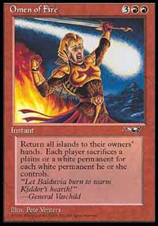
Not a card you see every day.
I did not phrase this particularly well - technically only two cards DESTROY COP: Red - they are Thunderscape Battlemage and Anarchy. The two other cards remove it from the game - they are Apocalypse (the card, not the expansion), and Telim'Tor's Edict (if you own the COP: Red). Another answer suggested to me by several readers is Omen of Fire, but I chose not to count it because it is conditional (an opponent might choose to sacrifice a Plains and keep the COP).
New Question:
A flavor text might surprise you sometimes. You may have been playing a card for months, and yet never realized that it has cool flavor text. Here are several samples from tournament-quality cards in Invasion. Can you figure out what cards they are from, without looking through your cards or an online database?
"Your presumption is your downfall"
"For his family, Barrin made a funeral pyre of Tolaria"
"Death's embrace need not be cold"
Please do not e-mail me your answers. The correct answer will be posted in next week's column.

BEST OF THE NET

Since quitting Magic, Jamie Wakefield eventually rose to the status of a patron saint of casual players. Star City reporter Sean E. Ponce recently tracked Jamie down for an interview. Not much about Magic there, but if you want to know what J.W. has been up to, this is your chance.

PLAY OF THE WEEK
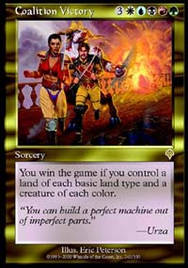
Before I go on to play of the week, I would like to give out an honorable mention. Since Invasion came out, I've been waiting to see a player pull off a Coalition Victory win in Limited. I am sure this has happened a number of times by now, but I finally got to witness one last weekend.
Steve Solomon managed to top-deck his way into all five colors of mana, and all the necessary creatures. He then used Diabolic Intent to search out his Coalition Victory, and triumphantly cast it next turn. Even so, Solomon came perilously close to losing that game - his opponent had an active Dream Thrush throughout most of the game, but used it to gate a Silver Drake into play that turn, thus unable to turn Solomon's single Mountain into another type of land, effectively countering Coalition Victory.
On to the play, from Glenn Godard:
"I was playing the U-W Nether Spirit deck you recommended. My opponent Roberto Gonzales was playing U-W Counter Rebel with Ankh Tide combo thrown in. He plays, I draw.
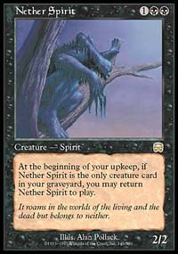
My initial draw contains
Island
Foil
Foil
Nether Spirit
Accumulated Knowledge
Wrath of God
Disenchant
I decide to keep reasoning that I have a Knowledge which can be active plus I need the Disenchant to deal with the Ankh. Plus heaven forbid I can Foil a real killer if I have to.
Play proceeds like this:
He play an Island.
I draw and discard the Nether Spirit
He plays a plains and an Ankh
I pull the Nether Spirit into play and draw, Argh no land Deciding not to play land till I can play a plains and Disenchant the Ankh, I pass.
He plays an island takes 2 from the Ankh (18) and passes
I draw no land, and attack (16)
He plays Brainstorm and plays a plains (14)
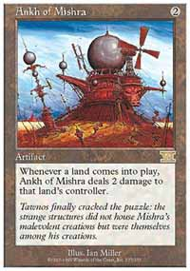
I draw and attack (12) at this point he begins to change from "I got this game" to "Oh crap I need a searcher now!"
He draw plays an island (10) and passes.
I draw an Island However with two Foils in hand and his Tide to perhaps be cast decide to wait. I attack (8)
He's really sweating now, plays a plains and hard casts a Jhovall Queen which I Foil. He's now at (6)
I draw (still no plains) attack (4)
He draws passes.
I attack (2) play an island while holding on to one for my other Foil
He draws. passes
I attack for the win
I never once tapped for mana, cast one spell and won the game.
Probably the one of the most entertaining games I have ever played."

BAD PLAY OF THE WEEK
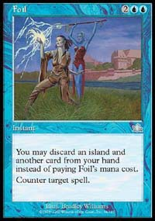
Our bad play also involves Foil, and was submitted by Kevin Eav:
"Friday Night Magic, I played my red-black deck vs. a blue counter deck (Blue Skies, I think). I cast a land destruction spell on a land-Stone Rain, I believe-and my opponent goes, "Check out this tech." He proceeds to Boomerang a land to his hand, and discarded the land, Foil, and one other card to counter the Stone Rain. Immediately after, the player to my right comments, "You know, you could have just Boomeranged the targeted land.""
As always, please send good/bad plays, cool trivia questions, and other news to ashv@concentric.net

